

**Exor 4.9.0**

Product Installation and Upgrade Guide

Document Version History

|  |  |  |  |  |
| --- | --- | --- | --- | --- |
| Version | Owner | Source | Date | Description |
| 1.0 | Chris Baugh | Author | 08-Jun-2018 | Initial Draft from previous release |
|  |  |  |  |  |
|  |  |  |  |  |
|  |  |  |  |  |
|  |  |  |  |  |
|  |  |  |  |  |
|  |  |  |  |  |
|  |  |  |  |  |
|  |  |  |  |  |
| For review: | | | | For approval: |
|  | | | |  |
|  | | | |  |
|  | | | |  |
|  | | | |  |
|  | | | |  |

Table of Contents

1 Introduction 5

1.1 Purpose 5

1.2 Products Covered by this Guide 5

1.3 Reference documents 5

2 Pre Installation/Upgrade 7

2.1 Prerequisites 7

2.2 Before you start 8

2.3 Unzipping Product Files 8

2.4 Typical problems that you may encounter 8

3 Post Installation/Upgrade 9

3.1 Additional Configuration 9

4 Network Manager 10

4.1 Database Server Install/Upgrade for Network Manager 10

4.1.1 Pre-Install of Network Manager 10

4.1.1.1 Highways Owner Account Creation 10

4.1.1.1.1 Tablespace Requirements 10

4.1.1.1.2 Data Dictionary Privileges 10

4.1.1.1.3 The higowner script 10

4.1.1.2 EXOR_CORE User and Objects 11

4.1.2 Pre-Upgrade of Network Manager 12

4.1.2.1 SYS Synonyms and Grants 12

4.1.2.2 SYSTEM Objects, Synonyms and Grants 12

4.1.2.3 EXOR_CORE Objects 13

4.1.3 Installation/Upgrade of Network Manager 13

4.1.4 Checking Log File(s) 14

4.2 Application Server Install/Upgrade for Network Manager 15

4.2.1 Deploy Product Binary files 15

4.2.2 Deploy Exor Forms 15

4.2.2.1 Prerequisites 15

4.2.2.2 Install the Exor Release 16

4.2.2.3 Deploy WebUtil 17

4.2.2.4 Configure the Forms Service to Use WebUtil 18

4.2.2.5 Configure TNSNAMES 28

4.2.2.6 Test Forms Logon 28

4.2.3 Deploy Exor Reports 30

4.2.3.1 Prerequisites 30

4.2.3.2 Add RW_ADMINISTRATOR role to user 30

4.2.3.3 Add User authentication details 32

4.2.3.4 Configure Reports environment 33

4.2.3.5 Start OHS 34

4.2.3.6 Start Reports Server 34

4.2.3.7 Testing Reports Server Configuration 35

4.2.3.8 Configure Exor Product Options 36

4.2.4 Deploy MapViewer 37

4.2.4.1 JRE Java settings 37

4.2.4.2 MV_SECURITY Option 39

4.2.4.3 Undeploying Any Existing Mapviewer 40

4.2.4.4 Deploy New Mapviewer 41

4.2.4.5 Define MapViewer Data Source 45

4.2.4.6 Configure Mapviewer Product Options 47

4.2.5 Deploy ORDS 48

1.1.1.1 Migrating DADS files to ORDS 56

4.2.5.1 Configuring WebLogic to Handle HTTP Basic Challenges Correctly 58

4.2.5.2 Test ORDS in Weblogic 59

4.2.6 Configure WebUtil 59

4.3 Post Install/Upgrade Tasks 61

4.3.1 Creation of Additional Database Objects 61

4.3.2 Synonyms 61

4.3.3 Process Framework 62

4.3.4 Jobs 62

4.3.5 Spatial Configuration 62

4.3.6 Spatial Theme Creation 62

4.3.7 Spatial Index creation 63

4.3.8 Mandatory Configuration 63

4.3.8.1 exor_version.txt 63

4.3.9 EXOR_JPG.JAR 63

4.3.10 Doc Bundle Loader 63

4.3.10.1 Oracle External Scheduler Jobs 63

5 Accidents Manager 65

5.1 Database Server Install/Upgrade for Accidents Manager 65

5.1.1 Install/Upgrade of Accidents Manager 65

5.2 Application Server Install/Upgrade for Accidents Manager 66

5.2.1 Deploy Product Binary files 66

5.3 Post Install/Upgrade Tasks 66

5.3.1 Mandatory Configuration 66

5.3.1.1 exor_version.txt 66

5.3.2 Product Licencing 66

6 Schemes Manager 67

6.1 Database Server Install/Upgrade for Schemes Manager 67

6.1.1 Install/Upgrade of Schemes Manager 67

6.2 Application Server Install/Upgrade for Schemes Manager 68

6.2.1 Deploy Product Binary files 68

6.3 Post Install/Upgrade Tasks 68

6.3.1 Mandatory Configuration 68

6.3.1.1 exor_version.txt 68

6.3.2 Product Licencing 68

7 Structures Manager 69

7.1 Database Server Install/Upgrade for Structures Manager 69

7.1.1 Install/Upgrade of Structures Manager 69

7.2 Application Server Install/Upgrade for Structures Manager 70

7.2.1 Deploy Product Binary files 70

7.3 Post Install/Upgrade Tasks 70

7.3.1 Mandatory Configuration 70

7.3.1.1 exor_version.txt 70

7.3.2 Product Licencing 70

# Introduction

## Purpose

This guide covers steps involved in installing/upgrading the Exor products listed in section 1.2 below.

Each product upgrade is split into two distinct stages,

Stage 1 – Implementation of the Software files

Stage 2 – Installation/Upgrade of the Server

## Products Covered by this Guide

The table below lists the relevant products that are covered by this guide.

|  |  |  |  |
| --- | --- | --- | --- |
| ***Product*** | Install | ***Upgrade*** | *Sequence* |
| Network Manager | 🗸 | 🗸 | 1 |
| Accidents Manager | 🗸 | 🗸 | 2 |
| Schemes Manager | 🗸 | 🗸 | 3 |
| Structures Manager | 🗸 | 🗸 | 4 |

The table above lists the order in which to install/upgrade the products in this release, as indicated by the *Sequence* column.

## Reference documents

|  |  |
| --- | --- |
| Oracle Support | Windows Java Client Hangs On Accepting Not Verified Signature Of jar Files When SeparateFrame=True (Doc ID 1173365.1) |
| Oracle Support | Form Hangs When Acknowledging Security Warning - The application's digital signature cannot be verified (Doc ID 1328039.1) |
| www.snapdba.com | <http://www.snapdba.com/2013/04/forms-11g-java-client-hangs-at-security-warning-with-the-applications-digital-signature-cannot-be-verified/> |
| Oracle Support | server-side SQLJ is no longer supported in Oracle 12.2. <https://community.oracle.com/thread/4036216>  <https://docs.oracle.com/en/database/oracle/oracle-database/12.2/upgrd/desupported-features-oracle-database-12c-r2.html#GUID-685A0333-1051-4306-B84A-574DAFE799B2> |
| Oracle Support | 12c: USE_SID_AS_SERVICE Setting in Listener Causes ORA-12514 Failures for Clients and Enterprise Manager (Doc ID 2099053.1)  <https://oracle-base.com/articles/12c/multitenant-connecting-to-cdb-and-pdb-12cr1> |

# Pre Installation/Upgrade

Important:

For the 4.9.0.0 release, Exor products will be installed on an Oracle 19c database. As a result, additional steps are required to accommodate differences to previous Database versions. When upgrading from a previous Exor version it is imperative that scripts detailed under Section 4.1.2**Error! Reference source not found.** are executed as the appropriate user.

## Prerequisites

It is assumed that the audience of this document understand the configuration of the servers being installed/upgraded and are sufficiently proficient with SQL*Plus. It is also assumed that the terminology used in this document is understood by the reader.

NB. The instructions for installation of the software describe the installation of all the software into a single area (usually referred to as the ‘Client’). The instructions for installing/upgrading the DB Server (your Highways schema) assume you have access to the database from the ‘Client’.

Your configuration and server access may differ from this; the supplied file can still be used for installation. For example, you may have to install the Client software on the Application Server and the Server software on the Database Server for reasons of database access availability from the Application Server.

If in any doubt, please raise a ticket at http://selectservices.bentley.com.

Before attempting to install/upgrade, you should ensure that;

* The Oracle database is version 19c and can be administered by an appropriate DBA.
* The appropriate third-party software components are installed and patched in accordance with the AssetWise LRS Certification Matrix.
* All users are disconnected from the system
* The process framework is shutdown (Note: This only applies if Exor Core is currently installed). This can be achieved by running the following when logged in to SQL*Plus as the Highways Owner:

begin

hig_process_admin.set_scheduler_state('DOWN');

end;

* A database backup of the Highways owner has been taken, if upgrading.
* When naming the <exor_base> directory and sub-directory structure (as discussed below) please ensure that the directory/folder string DOES NOT contain spaces.
* You MUST rename the current <exor_base> directory and sub-directory structure and contents to a new area (e.g. <exor_backup>). This ensures that a copy is available for backup or reference purposes should any issues arise during the installation.
* The installation can then continue into the area that the <exor_base> normally resides (which should now be empty).

## Before you start

Be aware of the following;

* Where instructed to change to a directory before running a script, it is assumed that you are running SQL*PLUS from a DOS Command prompt.
* If you are running SQL*PLUS in windows you should set the 'start in' directory of the SQL*PLUS shortcut to simulate the change of directory.

If you do not run SQL*PLUS from the directory stated in each step of the guide, the installation will fail.

## **Unzipping Product Files**

All exor applications that you install must be extracted into the same destination folder – this is referred to as <exor_base> throughout this document.

## Typical problems that you may encounter

It is possible that, when you are running some of the upgrade scripts, errors may be reported saying that objects already exist in the database or that columns already exist on tables. These errors can generally be ignored. If you are in any doubt, please contact the Bentley support desk for guidance.

The upgrade procedures will also attempt to install database roles in the highways owner account that are necessary for the system to operate correctly. You may find that errors are produced when running the upgrade scripts to the effect that the role names being created are already used by existing roles or users. These errors can be ignored as they simply mean that the roles being created already exist.

Also, during install/upgrade Warning messages may appear saying that compilation errors have occurred. These warnings can be ignored, since invalid objects will be recompiled later on in the install/upgrade. However, it will be of concern if compilation errors still occur following the re-compilation.

# Post Installation/Upgrade

Spatial Configuration Specific information regarding the registration of spatial layers can be found in the **Locator and Web Mapping** document.

## Additional Configuration

Consult the documentation that accompanies this release for details of any additional configuration that may be required following an install/upgrade.

For example, to obtain details of product options, and for details of new product features/amendments.

Important: It is highly recommended that you do this before attempting to use the application.

# Network Manager

Prior to Network Manager Installation or Upgrade, please refer to the **Pre Installation/Upgrade** section.

To install the software components for Network Manager first check that the NM3 folder is present and correctly unzipped from the release zip file.

Important:

All exor applications that you install must go into the same destination – often referred to as <exor_base>.

## Database Server Install/Upgrade for Network Manager

This section provides details of steps involved in installing/upgrading the database server components for Exor Core.

If this is a new installation, where Exor Core has not previously been installed, please follow the instructions detailed in section 4.1.1., otherwise follow the Upgrade instructions in section 4.1.2

### Pre-Install of Network Manager

#### Highways Owner Account Creation

This section provides details of steps involved in creating an owner for all Exor Core database objects.

It is important that you should only perform these steps if you do not already have a "Highways Owner" account.

The following paragraphs should be used to create a new schema for the implementation of Exor Core and any other subsequent application.

##### Tablespace Requirements

The following tablespaces (or equivalents) should be made available on your server:

* HIGHWAYS - Default Table Space. Can be a different name if required.
* TEMP - Default Temporary Tablespace for users. Can be a different name.

##### Data Dictionary Privileges

* Change directory to <exor_base>\nm3\install
* Login to SQL*PLUS as the **SYS** user on the client PC and run the following command:

start hig_sys_grants.sql

##### The higowner script

* Change directory to <exor_base>\nm3\install
* Login to SQL*PLUS as the **SYSTEM** user on the client PC and run the following commands:

start system_objects.sql

followed by:

start higowner.sql

This script will prompt you for the following information:

|  |  |
| --- | --- |
| Prompt | Meaning |
| Highways Owner Name | This should be the name to be given to your highways owner |
| Owner’s Password | Password for highways owner |
| Default Tablespace | Default Tablespace for highways owner |
| Temporary Tablespace | Temporary Tablespace for highways owner |
| System Start Date | This is the earliest date at which data is valid in your database |
| Admin Type Code | Code for the default admin unit type |
| Admin Type Description | Description for the default admin unit type |
| Admin Unit Code | Code for the default Admin Unit |
| Admin Unit Description | Description for the default Admin Unit |

You will now have a new Oracle user set up with all relevant privileges to run the highways application. Also, the system start date for your database will have been set and Top level Admin Unit created for your default Admin Unit Type.

#### EXOR_CORE User and Objects

The following should be used to create a new schema for the implementation of Context Setting.

* Change directory to <exor_base>\nm3\install
* Login to SQL*PLUS as the **SYSTEM** user on the client PC and run the following command:

start exor_core_user_creation.sql

* Login to SQL*PLUS as the **EXOR_CORE** user (Password EXOR_CORE) on the client PC and

run the following command:

start exor_core_objects.sql

Continue Installation by following the instruction in **Installation/Upgrade of Network Manager.**

### Pre-Upgrade of Network Manager

The following paragraphs should only be used to upgrade Exor Core. The current version must be at release 4.7.0.0, or later.

#### SYS Synonyms and Grants

The following should be used to add Synonyms and Grants for SYS objects. These are required to allow for IMS/Single Sign-On configuration.

* Change directory to <core_base>\nm3\install
* Login to SQL*PLUS as the **SYS** user on the client PC and run the following command:

start core_sys.sql

The following log file will be produced in the working directory, and should be checked for any errors that may have been produced:

core_sys_<date&time>.LOG

#### SYSTEM Objects, Synonyms and Grants

The following should be used to add Objects, Synonyms and Grants for SYSTEM objects. These are required as a result of Oracle 19c changes to Job Scheduling

* Change directory to <core_base>\nm3\install
* Login to SQL*PLUS as the **SYSTEM** user on the client PC and run the following command:

start core_system.sql

The following log file will be produced in the working directory, and should be checked for any errors that may have been produced:

core_system_<date&time>.LOG

#### EXOR_CORE Objects

Modifications have been made to objects owned by EXOR_CORE. These will require re-application.

* Change directory to <core_base>\nm3\install
* Login to SQL*PLUS as the **EXOR_CORE** user on the client PC and run the following command:

start exor_core.sql

The following log file will be produced in the working directory, and should be checked for any errors that may have been produced:

exor_core_<date&time>.LOG

Continue Upgrade by following the instruction in **Installation/Upgrade of Network Manager.**

### Installation/Upgrade of Network Manager

* Change directory to <core_base>\nm3\install
* Login to SQL*PLUS as the highways owner on the client PC and run the following command:

  start nm_inst.sql

You will be prompted to enter the path of the location of your highways software. This should be name of the directory, including disk identifier and a trailing slash character, referred to as <core_base>.

For example, if you installed your highways software in a directory called CORE on your C drive, you would enter the following when prompted.

C:\CORE\

When you have supplied this value, you will be prompted to confirm that it is correct and asked whether you wish to continue.

If the value specified is not correct or does not end with a slash character, you will be given an error message and the installation script will abort. You will then need to login to SQL*PLUS again and rerun the script.

When the script has completed, all the Exor Core objects and data will have been installed/upgraded.

### Checking Log File(s)

The following log files are produced in the working directory at the end of the installation/upgrade. These files can be viewed to check for any errors that could have occurred during installation.

For installation:

core4900_install_1_<date&time>.LOG

core4900_install_2_<date&time>.LOG

For upgrade:

core4900_upg_1_<date&time>.LOG

core4900_upg_2_<date&time>.LOG

**Note**: It is perfectly normal for the NM3SDE package to not compile if an SDE schema does not exist or if the highways owner has no privilege to read SDE objects.

Please raise and attach the logs to a ticket with <http://selectservices.bentley.com> to allow Bentley (formerly exor) support staff to verify the install has been successful.

## Application Server Install/Upgrade for Network Manager

Please note that this section is applicable when performing an install or upgrade for 4.9.0.0 (as opposed to previous releases). Please note that further configuration is required when installing the map server software and configuring the MapViewer product.

Please ensure that the Weblogic Application Server is installed, and Fusion Middleware Forms and Reports are installed and configured before proceeding.

Bentley-exor release 4.9.0.0 makes use of WebUtil functionality within the Oracle Weblogic Server Technology stack for Document Manager (uploading documents and Document Bundle Loader) and the Process Framework. This requires additional configuration within the Weblogic Server Fusion Middleware Forms deployment.

The Jar files being provided in this release have been signed. All Jar files will not require re-signing until January 2028. Please be aware that unsigned Jar files can lead to a potential issue whereby the forms start-up process will hang(Note: From Java 1.7.0_45 onwards, Forms will not just hang with expired versions of Jars, but the Jars will simply be blocked and user will be unable to launch the Exor application). For more information on the workaround please see documents on the Oracle support web site by referencing the documents below:

Windows Java Client Hangs On Accepting Not Verified Signature Of jar Files When SeparateFrame=True (Doc ID 1173365.1)

Form Hangs When Acknowledging Security Warning - The application's digital signature cannot be verified (Doc ID 1328039.1)

Alternatively see:

<http://www.snapdba.com/2013/04/forms-11g-java-client-hangs-at-security-warning-with-the-applications-digital-signature-cannot-be-verified/>

### Deploy Product Binary files

Copy the contents of the **<exor_base>\nm3\11g_bin** and **<exor_base>\nm3\admin\c\11g_exe** folders to a new working directory (e.g. C:\exor\4900\bin), often referred to as the **bin folder.** This will be the location of the Forms/Reports modules and ‘C’ executablesthat are configured in the associated deployment sections below.

### Deploy Exor Forms

Forms configuration must **only** be performed using WebLogic Enterprise Manager, and not by manually editing the underlying files. This ensures that the controlling XML files are correctly maintained and that the Fusion Middleware services continue to function. Manual editing of files may result in the corruption of services and must not be undertaken unless this involves the close supervision of Bentley support staff.

#### Prerequisites

Exor 4900 Forms requires an Oracle Fusion Middleware 12.2.1.4.0 base installation.

#### Install the Exor Release

Copy the following files from <exor_base>/admin/lib to <ORACLE_HOME>\forms\java directory on the Oracle WebLogic Server:

bouncy-castle-provider.jar  
commons-codec.jar  
DJNativeSwing-SWT.jar  
DJNativeSwing.jar  
esapi.jar  
exor-mapviewer.jar  
exor_jpg.jar  
exor_login_util.jar  
jacob.jar  
log4j.jar  
log4j.properties  
mvclient.jar  
ojdbc6.jar  
swt.jar  
UploadClient.jar  
UploadServer.jar

#### Deploy WebUtil

Copy **jacob-1.14.3-x86.dll** from <exor_base>/admin/lib to <ORACLE_HOME>\forms\webutil\win32:

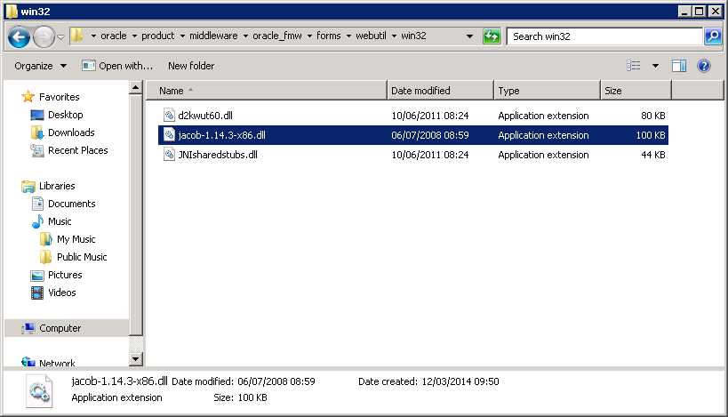

Copy **jacob-1.14.3-x64.dll** from <exor_base>/admin/lib to <ORACLE_HOME>\forms\webutil**\**forms\webutil\win64:

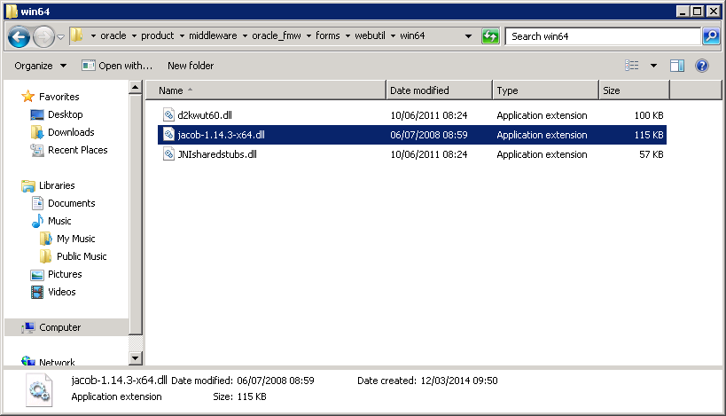

#### Configure the Forms Service to Use WebUtil

* Launch WebLogic Enterprise Manager in a browser (http://localhost:7001/em):
* Navigate to Forms > forms:

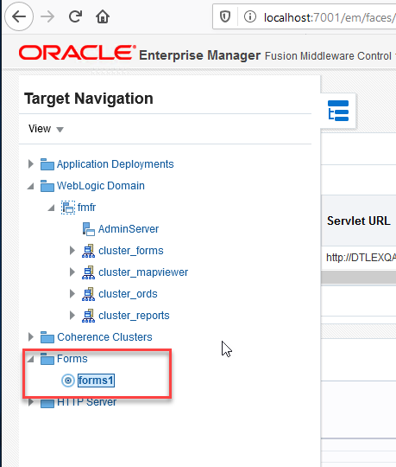

* Select ‘Font and Icon Mapping’ from the drop-down menu:

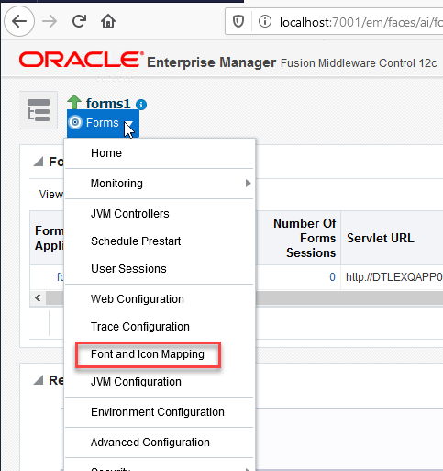

* Select ‘Lock & Edit’ from the drop-down list

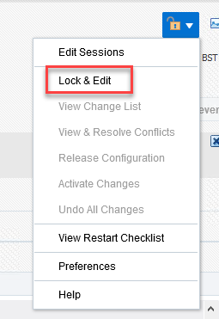

* Scroll down to **default.icons.extension**, activate edit session using change to ‘jpg’ and click Apply
* Activate the changes:

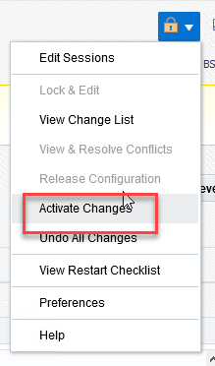

* Select Forms menu > ‘Web Configuration’:

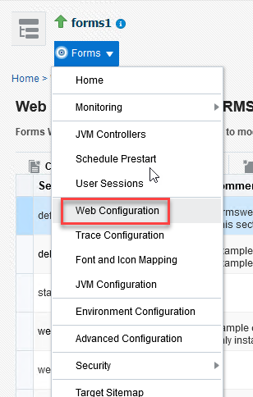

* Select show ‘all’:

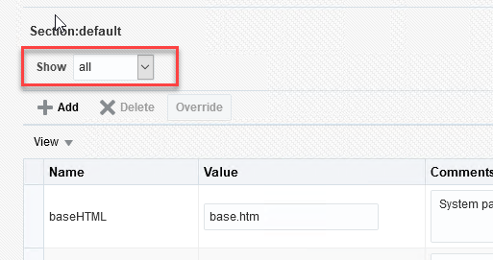

* Select ‘Lock & Edit’ from the drop-down list
* Update the following parameters:

|  |  |
| --- | --- |
| background | bgnd2.gif |
| form | hig1807.fmx |
| height | 768 |
| highContrast | true |
| java_version | 1.8+ |
| jpi_classid | clsid:CAFEEFAC-0018-0000-FFFF-ABCDEFFEDCBA |
| jpi_download_page | http://yourhost.online.local:8888/jre/jre-8u251-windows-i586.exe |
| jpi_mimetype | application/x-java-applet;jpi-version=1.8 |
| legacy_lifecycle | true |
| networkretries | 30 |
| pageTitle | Closing this window will exit “Highways by Bentley” |
| separateFrame | true |
| splashScreen | no |
| term | C:\Oracle\Product\Middleware\Oracle_Home\user_projects\domains\fmfr\config\fmwconfig\components\FORMS\instances\forms1\fmrpcweb.res |
| width | 1024 |

* Click on Apply:

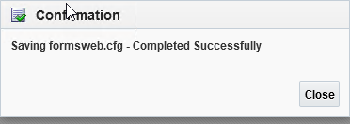

* Click on ‘Add’ to add the new parameters:

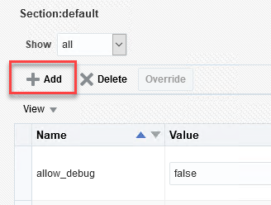

* Add the following parameters:

|  |  |
| --- | --- |
| pjcRegisterApplet | exor.mapserver.RegisterCertificate |
| webUtilArchive | jacob.jar,frmwebutil.jar |
| webUtilLogging | on |
| webUtilLoggingDetails | normal |
| webUtilErrorMode | console |
| webUtilDispatchMonitorInterval | 5 |
| webUtilTrustInternal | true |
| webUtilMaxTransferSize | 16384 |

* Click Apply:



* Activate the changes:



* Once the new values are added we will create a new forms configuration (ie Forms bin area).
* Select ‘Lock & Edit’ from the drop-down list
* Select ‘Create’ to add a new section for the Bentley Exor environment:

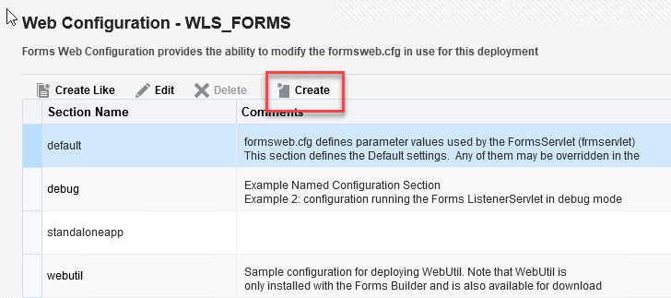

* Click Create and enter an appropriate name (in this example it’s ‘4900’) for the forms configuration:

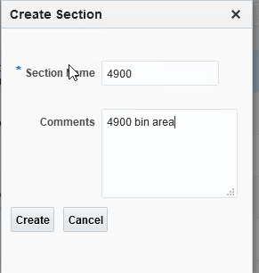

* Highlight the new section and change the view to ‘all’:

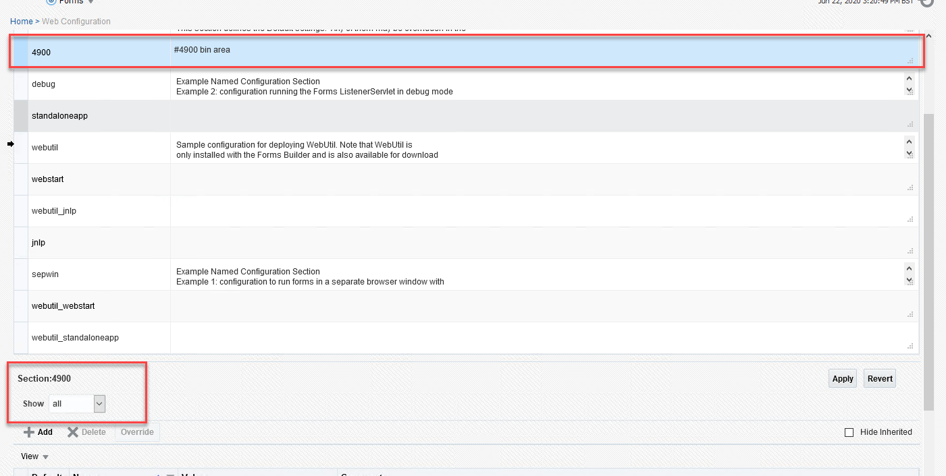

* Click on ‘Add’ again to add new parameters:

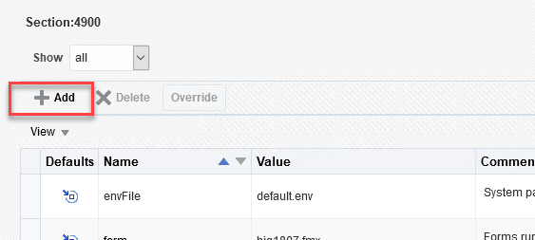

* Add the following parameters:

|  |  |
| --- | --- |
| pjcArchive | exor-mapviewer.jar |
| workingDirectory | C:\exor\4900\bin (This is the forms/reports bin folder) |

* Highlight **envFile** parameter and click *Override*

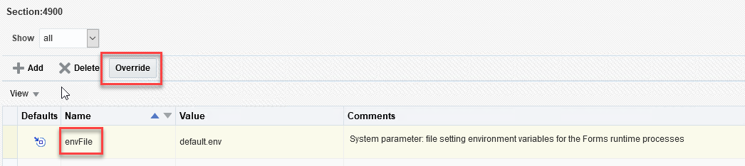

* Change default.env to an appropriate environment name eg. 4900.env



* Highlight **baseHTML.jpi** parameter and set the value to ‘webutiljpi.htm’
* Highlight **archive** and set the value to:

frmall.jar,exor_jpg.jar,UploadClient.jar,exor-mapviewer.jar,mvclient.jar

* Click Apply:



* Activate the changes:



You can create multiple configurations if the system is to support both live and test applications.

* Copy the contents of the **[EXOR_BASE]\nm3\bin** folder to the new working directory as specified above (e.g. C:\exor\4900\bin)
* Select Forms menu > ‘Environment Configuration’:

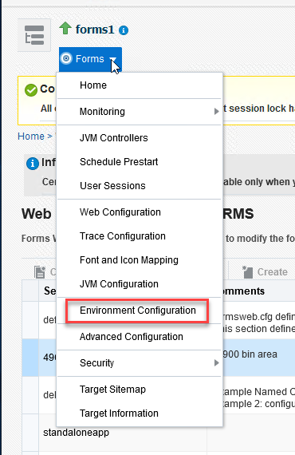

* With default.env as the current environment file selected, press the *Duplicate File* button.

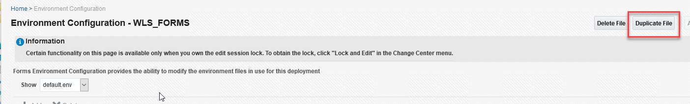

* Name the environment file with the name used in the envFile parameter previously (eg 4900.env), and press *Duplicate*

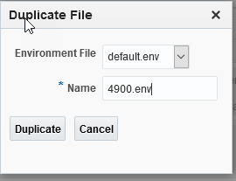

* Select the newly created environment file from the dropdown list.

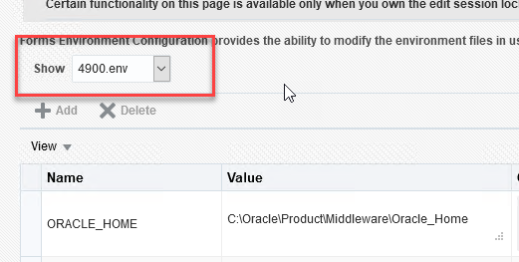

* Locate the CLASSPATH parameter, Click *Lock & Edit* and add the following value, making sure to separate each of the values using a semi-colon (;):

<Oracle Home>\forms\java\UploadServer.jar;

e.g C:\Oracle\Product\Middleware\Oracle_Home\forms\java\UploadServer.jar

* Locate FORMS_PATH and add the new working directory as specified above (e.g. C:\exor\4900\bin) to the end, separating by a semicolon ‘;’;
* Click Apply:
* Click on ‘Add’ again to add new parameters:



* Add the following parameters:

|  |  |
| --- | --- |
| FORMS_REJECT_GO_DISABLED_ITEM | FALSE |
| FORMS_USERNAME_CASESENSITIVE | 1 |

* Click Apply:



* Activate the changes:



#### Configure TNSNAMES

* Locate the TNSNAMES.ORA file in C:\Oracle\Product\Middleware\Oracle_Home\user_projects\domains\fmfr\config\fmwconfig
* Edit TNSNAMES.ORA to include a new database entry. In the following example the database instance is called AUTHTEMP and the server has been identified by its IP address (a fully qualified name can also be used):

ABC123=

(DESCRIPTION=

(ADDRESS=

(PROTOCOL=TCP)

(HOST=dbhost.server.com)

(PORT=1521)

)

(CONNECT_DATA=

(SERVER=dedicated)

(SERVICE_NAME=service name)

)

)

NB: highlighted values need to be changed to appropriate values for your Database connection

* Launch a command window and enter the following to test the TNSNAMES entry just created:

tnsping <DB Name>

Where DB Name is the instance name just added to TNSNAMES, you should get a result similar to the following:

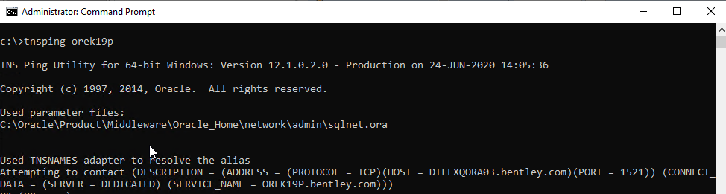

#### Test Forms Logon

* Prior to testing forms, edit the **exor_versions.txt** file contained in the Forms bin folder. Ensure that all product versions are correct for any Exor products licensed on the Database. If any versions in the file differ from those on the Database, the associated forms for that product will not appear in the launchpad.
* Using a browser on a client machine with the appropriate version of Java JRE installed, connect to the following URL, replacing the highlighted field with the server name or IP address of your application server:

http://<Apps Server Name>:9001/forms/frmservlet?config=<Forms config>

Where <Apps Server Name> = Name of Application Server

<Forms config> = Forms config name defined in 4.2.2.4

The Exor logon screen should appear:

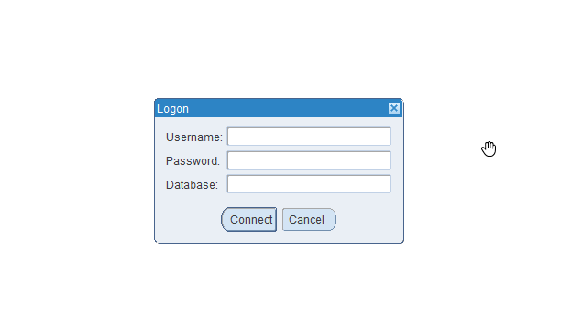

* After entering the required values the Exor launchpad should appear:

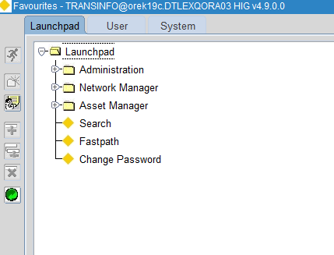

### Deploy Exor Reports

Reports configuration must **only** be performed using WebLogic Enterprise Manager, and not by manually editing the underlying files. This ensures that the controlling XML files are correctly maintained and that the Fusion Middleware services continue to function. Manual editing of files may result in the corruption of services and must not be undertaken unless this involves the close supervision of Bentley support staff.

#### Prerequisites

Exor 4900 Forms requires an Oracle Fusion Middleware 12.2.1.4.0 base installation.

#### Add RW_ADMINISTRATOR role to user

* Launch WebLogic Enterprise Manager in a browser (http://localhost:7001/em):
* Go to Menu--> Security --> Application Roles

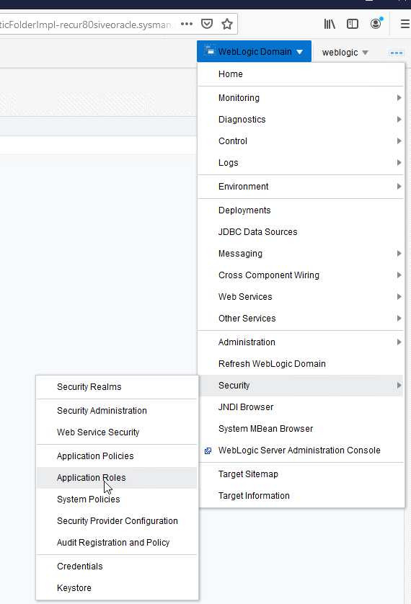

* Select **reports** for "Application Stripe" and hit **Search** (ie )

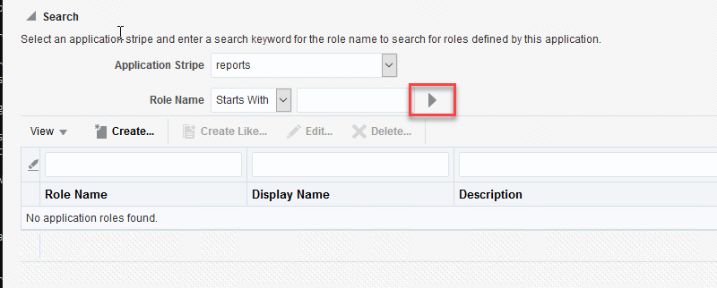

* Select **RW_ADMINISTRATOR** -**-> Edit**

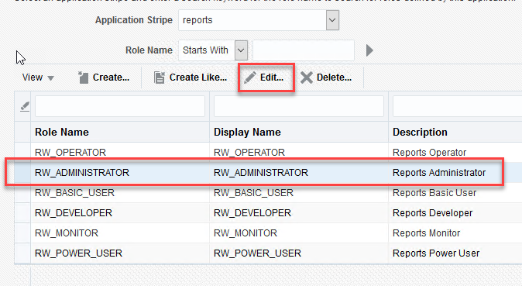

* Select **Add** (under Members)

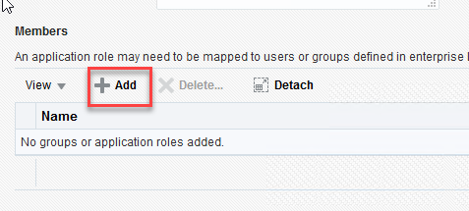

* Select **Type: User** and hit **Search** (ie )

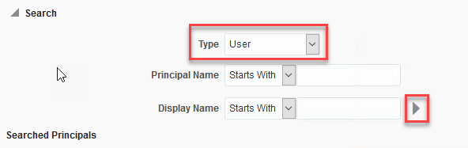

* Select **weblogic**_user

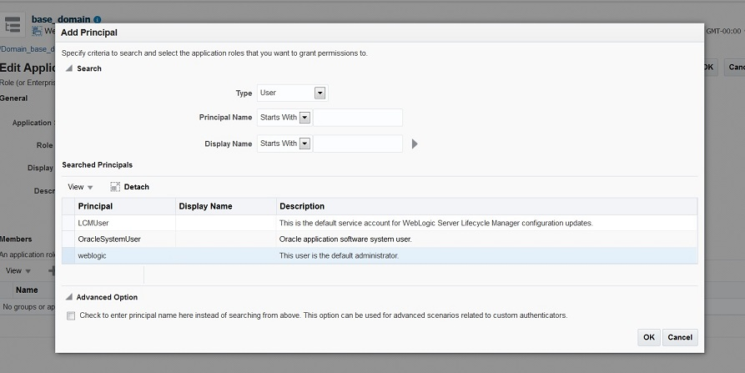

* Hit **OK**
* Hit **OK**, again
* You can see now that RW_ADMINISTRATOR role has **weblogic** as one of its members:

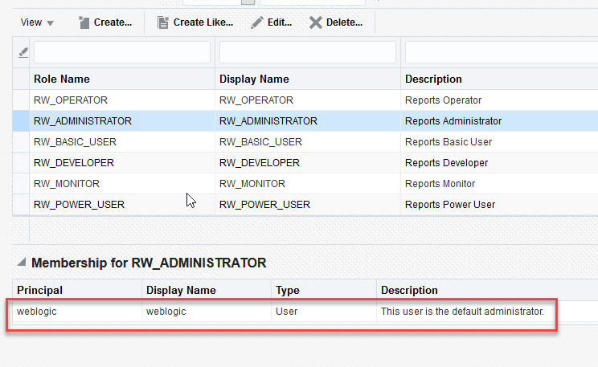

* Restart WLS_REPORTS.

#### Add User authentication details

* Open a Command window as Administrator and change directory to:

DOMAIN_HOME\config\fmwconfig

Eg. C:\Oracle\Product\Middleware\Oracle_Home\user_projects\domains\fmfr\config\fmwconfig

* Back up system-jazn-data.xml file, then edit the file to add the following entries:

<jazn-realm default="jazn.com">

<realm>

<name>jazn.com</name>

<users>

<user>

<name>weblogic</name>

<credentials>!<Weblogic password></credentials>

</user>

</users>

</realm>

Where <Weblogic password> is the weblogic user password

#### Configure Reports environment

* Open a command window as Administrator and change directory to:

DOMAIN_HOME/bin

Eg. C:\Oracle\Product\Middleware\Oracle_Home\user_projects\domains\fmfr\bin

* Backup rwserver.conf, then add environment settings below the following line:

<engine id="rwURLEng" class="oracle.reports.urlengine.URLEngineImpl" maxEngine="1" minEngine="0" engLife="50" />

* As follows:

<environment id="<Environment name>">

<envVariable name="REPORTS_PATH" value="<Report Path>"/>

</environment>

Where <Environment name> = Reports config name

<Report Path> = Path to reports bin area

Eg.

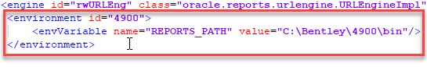

* Locate the following line:

<job jobType="report" engineId="rwEng" securityId="rwJaznSec"/>

* And remove securityId="rwJaznSec"

i.e.

<job jobType="report" engineId="rwEng"/>

#### Start OHS

* Launch WebLogic Enterprise Manager in a browser (http://localhost:7001/em):
* Start ohs1 from Control->Start Up

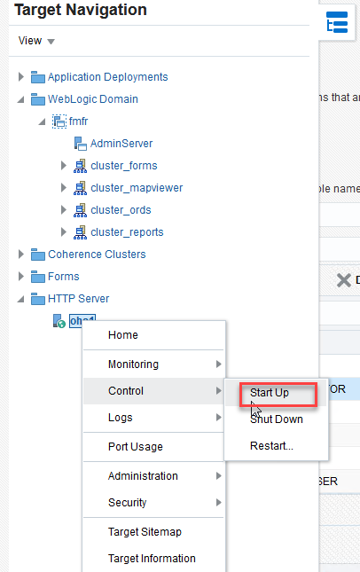

#### Start Reports Server

* Open a command window as Administrator and change directory to:

DOMAIN_HOME/bin

Eg. C:\Oracle\Product\Middleware\Oracle_Home\user_projects\domains\fmfr\bin

* Issue the following command:

startComponent repsvr_<Server Name> storeUserConfig

enter weblogic password when prompted

This will start the reports server and save configuration details to allow for auto-restart

* Launch WebLogic Console in a browser (http://localhost:7001/console) and restart the reports server (ie WLS_REPORTS)

#### Testing Reports Server Configuration

* To test the Reports Server configuration use a URL similar to:

http:/<Reports Server>:9002/reports/rwservlet/showenv?server=<Reports Server Instance>

Where <Reports Server> = fully qualified server name

<Reports Server Instance> = Report Server Instance defined in **Error! Reference source not found.**

Eg:

http://dtlexqapp06.bentley.com:9002/reports/rwservlet/showenv?server=repsvr_dtlexqapp06

* When prompted enter the Weblogic username and password. If successful a screen similar to the following will be returned:

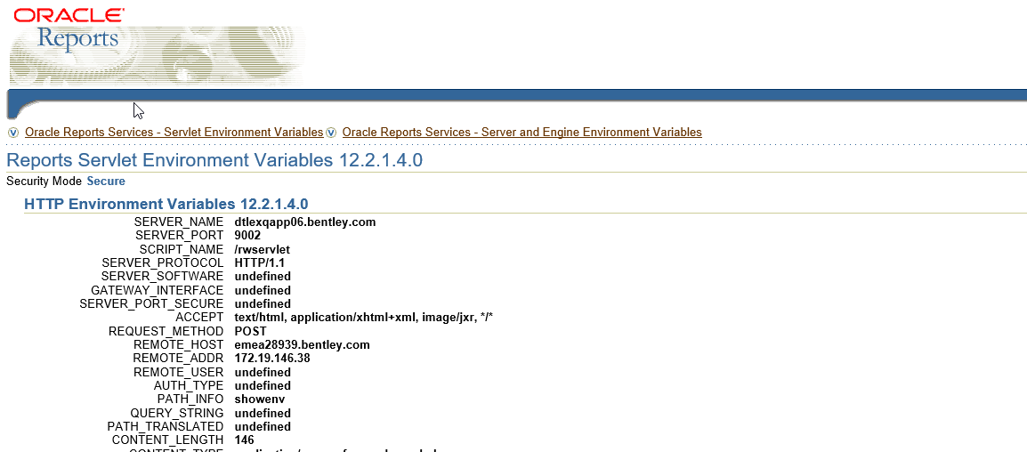

#### Configure Exor Product Options

* In order for Reports to be configured you must have a working Forms installation. Launch the Forms application using the standard URL, then navigate to the **exor > Reference Data > Product Options**:

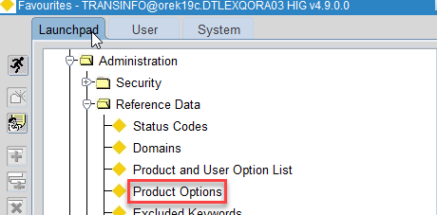

* Click the Enter Query button, enter the product option **NOT_6I_REP**, then click the Execute Query button. Set the Current Value to ‘Y’ and click Save:

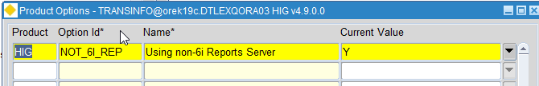

* Query **REPURL** and set this to a URL as follows:

http:/<Reports Server>:<Port>/reports/rwservlet/server=repsvr_<Reports Server Instance>&envid=<Environment Name>

Where <Port > = is generally set to 9002 but you can check in the WebLogic Console

<Reports Server> = fully qualified server name

<Reports Server Instance> = Report Server Instance defined in **Error! Reference source not found.**

<Environment name> = Reports config name specified in 4.2.3.4

### Deploy MapViewer

#### JRE Java settings

On each client machine the Jar Cache will need to be cleared. This can be done by the following methods.  
Oracle JRE users:

* Open Windows Control Panel and open Java Control Panel as below -

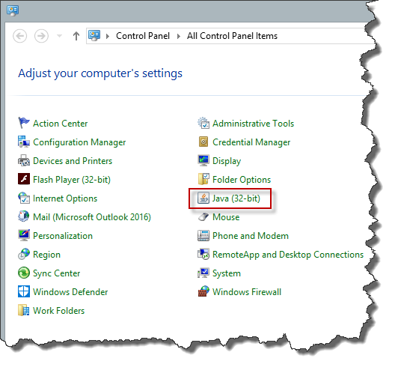

* Navigate to the "General" tab and click "Settings" button.

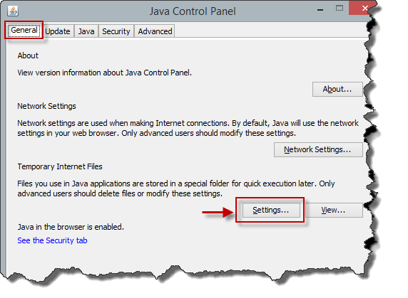

* In the Disk Space section click "Delete Files" button, select all options in the resulting screen and press OK

|  |  |
| --- | --- |
| C:\Users\CHRIS~1.BAU\AppData\Local\Temp\SNAGHTML7f0a27.PNG | C:\Users\CHRIS~1.BAU\AppData\Local\Temp\SNAGHTML7fdcaa.PNG |

When you launch the Exor Application for the first time a java security warning will appear. Select the checkbox in front of ‘Do not show this again for apps from the publisher and location above’ as shown in the following screenshot and then click Run –

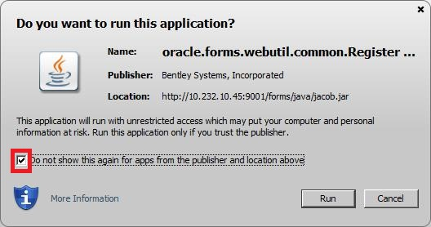

Again, open the Java Control Panel as described above. In the Java Control Panel go to –

Security -> Manage Certificates…

Now you will see the Bentley Systems, Incorporated Certificate installed and listed under Trusted Certificate.

|  |  |
| --- | --- |
| C:\Users\CHRIS~1.BAU\AppData\Local\Temp\SNAGHTML8482e9.PNG | C:\Users\CHRIS~1.BAU\AppData\Local\Temp\SNAGHTML857bd0.PNG |

Close the Java Control Panel.

After this, you should not see any warnings in future, unless the certificate gets removed.

You should now load the Exor Application in the usual way. On the first load, it will take longer than usual whilst the JAR files are cached again.

#### MV_SECURITY Option

Please ensure that the MV_SECURITY option in the Mapviewer config file is set to FALSE. This has to be set to FALSE so that the Java code can create a data source on the fly when the preferred data source is not set.

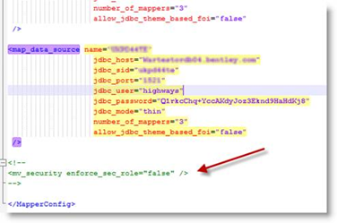

#### Undeploying Any Existing Mapviewer

* Log on to the **Oracle WebLogic MapViewer Server Admin Console** page.
* Go to **Domain Structure** > **Deployments**.
* On the **Summary of Deployments** page, select the existing mapviewer application and click on **Stop** > **Force Stop Now** (above/below the Deployments list), follow the next screen and confirm the stopping by clicking on **Yes** button.
* If WebLogic Server was configured in **Production** mode, lock the server: click on **Lock & Edit** button.
* Again, select the existing mapviewer application from the list and click on **Delete** button (above/below the Deployments list), follow the next screen and confirm the deleting by clicking on **Yes** button.
* If WebLogic Server was configured in **Production** mode, click **Activate Changes** to remove the old deployment completely.

#### Deploy New Mapviewer

Launch WebLogic Enterprise Manager in a browser (http://localhost:7001/console) and highlight **‘Servers’** under Domain Structure:

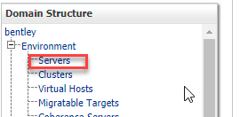

Select the ‘Control’ Tab, select the checkbox next to the Mapview Server, eg: WLS_MAPVR and force shutdown:

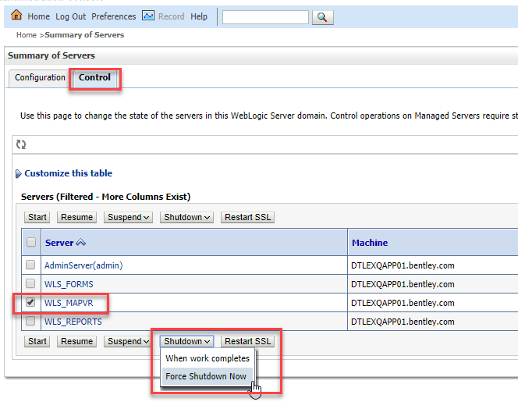

* Create a directory named **mapviewer**, in an appropriate folder eg. C:\Oracle\Product\Middleware\mapviewer
* Copy **mapviewer.ear** from <exor_base>/admin/lib into the newly created **mapviewer** directory.
* Unpack **mapviewer.ear**into folder **mapviewer**
* Delete **mapviewer.ear** and rename folder **mapviewer** to **mapviewer.ear**
* Go to the **mapviewer.ear** directory.
* Unzip **web.war** into folder **web**
* Delete **web.war** and rename folder **web** to **web.war**
* Modify the MapViewer configuration file (\mapviewer\mapviewer.ear\web.war\WEB-INF\conf\mapViewerConfig.xml) as needed, such as to change the logging level or to add permanent data source definitions. You can also modify this configuration file at any time later.
* Start the Mapviewer server in the Oracle WebLogic MapViewer Server Admin Console:

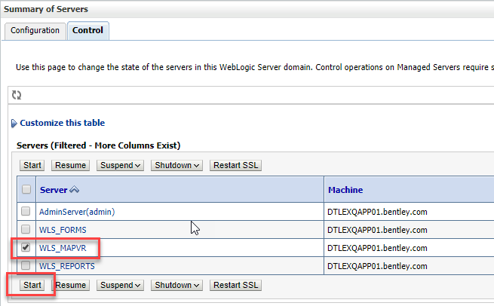

* Click on **Lock & Edit** button.
* Go to Domain Structure > Deployments.
* On the **Deployments** page, click on the **Install** button (above/below the list of deployments).

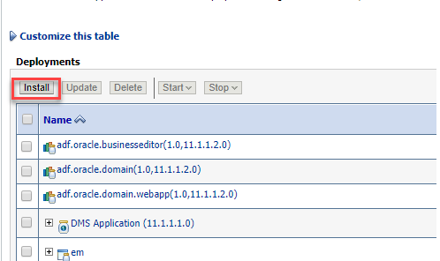

* In the **Install Application Assistant**, under **Locate deployment to install and prepare for deployment**, populate the **Path** entry to **mapviewer** directory path( eg C:\Oracle\Product\Middleware\mapviewer), or navigate to the directory by highlighting the folders under Current Location. Select



and click Next.

* Under **Choose targeting style**, accept the default (**Install this deployment as an application**), and click **Next**.
* In the **Select deployment targets**, under **Servers** select the **cluster_mapviewer** and click **Next**

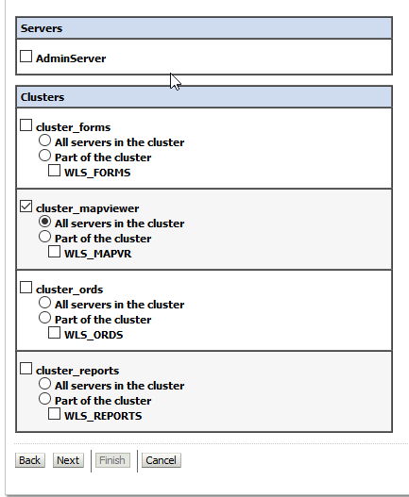

* Under **Optional Settings**, accept the defaults except under **Source Accessibility**, select **I will make this deployment accessible from the following location** and click **Finish**
* Click **Activate Changes** to activate the deployment.
* **Start** MapViewer as follows:

1. On the **Summary of Deployments** page select the **Control** Tab and select the just installed mapviewer from the list.

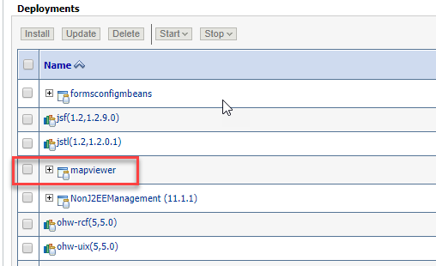

1. Click Start > Servicing all requests (above/below the Deployments list) and confirm the start by clicking on the **Yes** button on the following page

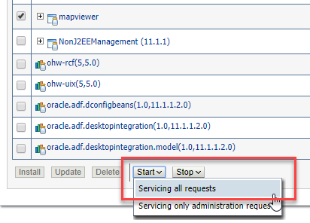

1. MapViewer should now be started (with State: Active and Health: OK).

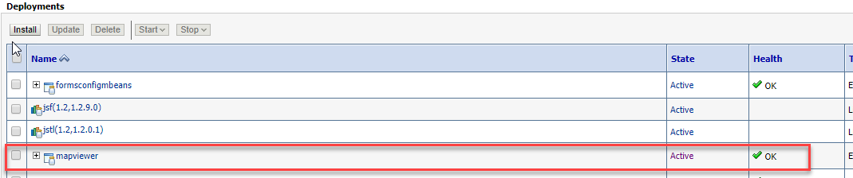

#### Define MapViewer Data Source

* Launch Mapviewer in a browser (http://<Hostname>:9003/mapviewer)
* Enter the weblogic username and password when prompted
* Select **Configuration** From the menu options.

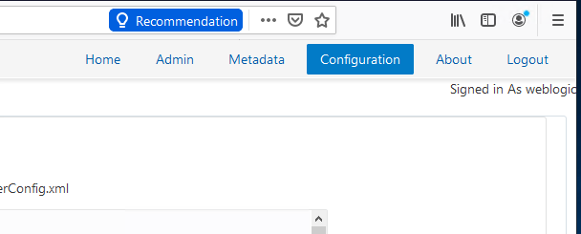

* The Mapviewer configuration screen should be displayed, allowing for config changes:

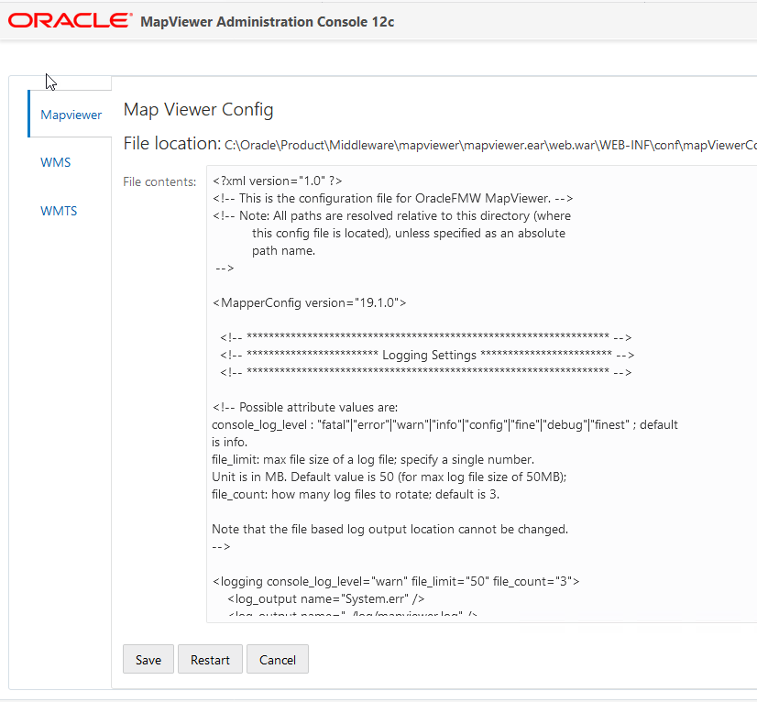

* Scroll down to **Predefined Data Sources:**

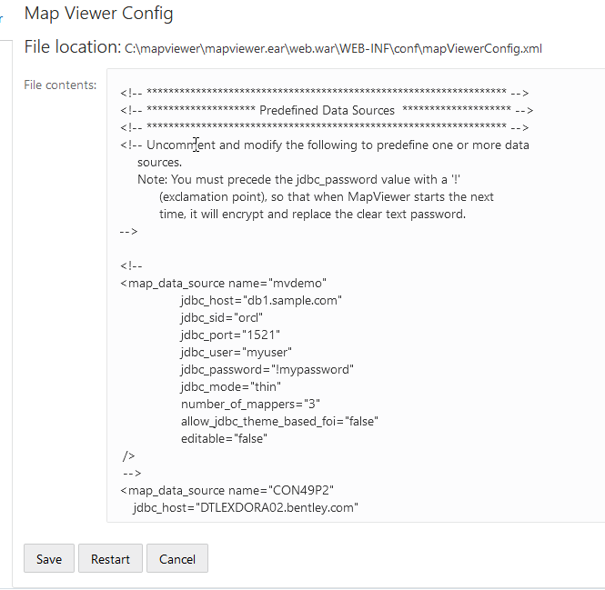

* Add an entry below the mvdemo example for the required Database as follows:

<map_data_source name="**<Data Source Name>**"

jdbc_host="**<Database Host>**"

jdbc_sid="//**<Service Name>**"

jdbc_port="**<Port No.>**"

jdbc_user="**<Username>**"

jdbc_password="!**<Password>**"

jdbc_mode="thin"

number_of_mappers="21"

max_connections="100"

allow_jdbc_theme_based_foi="false"

editable="false"

plsql_package="**web_user_info**"

web_user_type="**SUBUSERNAME**"

/>

Where:

**<Data Source Name> =** Name of the data source

**<Database Host> =** Host definition for the database connection required

**<Service Name> =** Service Name defined for the database connection

**Important: The *Service Name* value must be preceded by 2 forward slashes (ie ‘//’)**

**<Port No.> =** Port number for the database connection

**<Username> =** Username of the Highways Owner defined on the database

**<Password> =** Password of the Highways Owner

* Click **Save** followed by **Restart**.
* Restart WebLogic Forms and MapViewer Servers – e.g. **WLS_FORMS** and **WLS_MAPVR** – for the above changes to take effect.

#### Configure Mapviewer Product Options

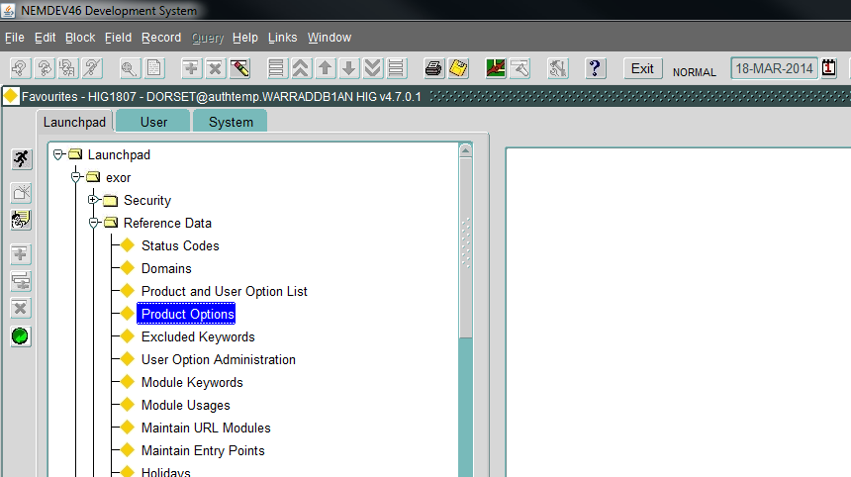

* Click the Enter Query button , enter **WMP** under Product and click Execute Query .
* Update the following product options:

|  |  |
| --- | --- |
| JDBCHOST | JDBC Server Host Name. This will correspond with **<Database Host>,** above |
| JDBCPORT | JDBC Port for Host Connection. This will correspond with**<Port No.>,** above**.** |
| JDBCSID | Oracle SID for JDBC Connection. This will correspond with**<Service Name>,** above.(ie without preceding ‘//’) |
| WEBMAPDSRC | Name of the JDBC Data Source connecting map server to RDBMS. This will correspond with **<Data Source Name>,** above. |
| WEBMAPMSV | URL to specify the Oracle Mapviewer Servlet. The URL will be constructed as follows:  **<MapServer Name>:<Mapserver Port>/mampviewr/omserver**  **Eg.** **http://dtlexqapp06.bentley.com:9003/mapviewer/omserver** |

### Deploy ORDS

1. Download release 19.2 of Oracle Rest Data Services (JDBC Driver is not required) from the following location:

<https://www.oracle.com/database/technologies/appdev/rest-data-services-v192-downloads.html>

1. Create a directory named **ORDS**, in an appropriate folder eg. C:\Oracle\Product\Middleware\ORDS
2. Unzip the downloaded file (ords-19.2.0.199.1647.zip) into the newly created folder
3. Launch WebLogic Enterprise Manager in a browser (<http://localhost:7001/console>) and highlight ‘Servers’ under Domain Structure:



1. Select the ‘Control’ Tab, select the checkbox next to the ORDS Server, eg: WLS_ORDS and force shutdown:

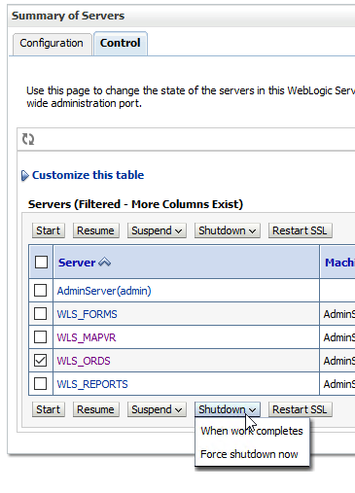

1. Locate ords_params.properties in the **ORDS**/params directory. Take a backup copy of the file then modify the parameters as follows:

|  |  |
| --- | --- |
| db.hostname | ORDS DB hostname |
| db.port | ORDS DB Port |
| db.servicename | ORDS DB Service Name |
| db.username | ORDS DB username |
| migrate.apex.rest | false |
| rest.services.apex.add | false |
| rest.services.ords.add | true |
| schema.tablespace.default | ORDS DB default tablespace name |
| schema.tablespace.temp | ORDS DB temporary tablespace name |
| standalone.http.port | 8080 |
| standalone.static.images |  |
| user.tablespace.default | ORDS DB default User tablespace name |
| user.tablespace.temp | ORDS DB temporary User tablespace name |

1. Open a command window as Administrator and change directory to the **ORDS** directory**.**
2. Issue the following command:

java -jar ords.war install advanced

You will be prompted for the following entries (Note default values in square brackets i.e.’[]’. Most of these will be as specified in ords_params.properties, above.

|  |  |
| --- | --- |
| Prompt | Value |
| Enter the location to store configuration data: | Path to ORDS config i.e. C:\Oracle\Product\Middleware\ORDS |
| Enter the name of the database server [<ORDS DB server>]: | Accept default value |
| Enter the database listen port [1521]: | Accept default value |
| Enter 1 to specify the database service name, or 2 to specify the database SID [1] | Enter 1 to specify DB Service Name |
| Enter the database service name | Accept default value |
| Enter 1 if you want to verify/install Oracle REST Data Services schema or 2 to skip this step [1] | Enter 1 |
| Enter the database password for ORDS_PUBLIC_USER | Enter appropriate password |
| Confirm password | Confirm password |
| Enter the administrator username | SYS |
| Enter the database password for SYS AS SYSDBA | Enter SYS password |
| Confirm password | Confirm SYS password |
| You will be prompted to enter tablespace names | Use default value or modify to appropriate tablespace name |
| If using Oracle Application Express or migrating from mod_plsql then you must enter 1 [1] | Enter 1 |
| Enter the PL/SQL Gateway database user name [<ORDS DB username>] | Accept default value |
| Enter the database password for apex_public_user | Enter password for ORDS DB username |
| Confirm password | Confirm password |
| Enter 1 to specify passwords for Application Express RESTful Services database users (APEX_LISTENER, APEX_REST_PUBLIC_USER) or 2 to skip this step [1] | Enter 2 |

You should receive messages similar to the following:

Enter the name of the database server [dtlexqora03.bentley.com]:

Enter the database listen port [1521]:

Enter 1 to specify the database service name, or 2 to specify the database SID [1]:

Enter the database service name [ENFQ49P.bentley.com]:

Enter 1 if you want to verify/install Oracle REST Data Services schema or 2 to skip this step [1]:

Enter the database password for ORDS_PUBLIC_USER:

Confirm password:

Requires to login with administrator privileges to verify Oracle REST Data Services schema.

Enter the administrator username:sys

Enter the database password for SYS AS SYSDBA:

Confirm password:

Retrieving information.

Enter the default tablespace for ORDS_METADATA [SYSAUX]:

Enter the temporary tablespace for ORDS_METADATA [TEMP]:

Enter the default tablespace for ORDS_PUBLIC_USER [USERS]:

Enter the temporary tablespace for ORDS_PUBLIC_USER [TEMP]:

Enter 1 if you want to use PL/SQL Gateway or 2 to skip this step.

If using Oracle Application Express or migrating from mod_plsql then you must enter 1 [1]:

Enter the PL/SQL Gateway database user name [highways]:

Enter the database password for highways:

Confirm password:

Enter 1 to specify passwords for Application Express RESTful Services database users (APEX_LISTENER, APEX_REST_PUBLIC_USER) or 2 to skip this step [1]:2

Jun 30, 2020 4:52:04 PM

INFO: reloaded pools: [|apex||, |enfq49p||, |orek19p||, |orek19p - copy||, |enfq49p|pu|]

Installing Oracle REST Data Services version 19.2.0.r1991647

... Log file written to C:\Users\adminu\ords_install_core_2020-06-30_165204_00856.log

... Verified database prerequisites

... Created Oracle REST Data Services proxy user

... Created Oracle REST Data Services schema

... Granted privileges to Oracle REST Data Services

... Created Oracle REST Data Services database objects

... Log file written to C:\Users\adminu\ords_install_datamodel_2020-06-30_165230_00059.log

... Log file written to C:\Users\adminu\ords_install_apex_2020-06-30_165232_00977.log

Completed installation for Oracle REST Data Services version 19.2.0.r1991647. Elapsed time: 00:00:30.923

Enter 2 when prompted to start in standalone mode

1. Log onto SQL*Plus as the Highways Owner and issue the following command:

**begin**

**ords.enable_schema;**

**commit;**

**end;**

**/**

1. Configure connection pool for ORDS DB connection

* Issue the following command:

java -jar ords.war setup --database <ORDS DB SID>

When prompted, use the same values from the table in 9., above.

1. Create a URL mapping for the application

* Issue the following command:

java -jar ords.war map-url --type base-path /<ORDS DB SID> <ORDS DB SID>

You should receive confirmation similar to:



1. Test ORDS in stand-alone mode

* Issue the following command:

java -jar ords.war standalone

Note: You will be prompted to use HTTP or HTTPS . Choose option 1 (HTTP). Accept the default port of 8080 when also prompted.

* Test using the following URL:

http://<ORDS DB ServerName>:8080/ords/nm3web.main_menu

On successful configuration, you should be presented with a screen like:

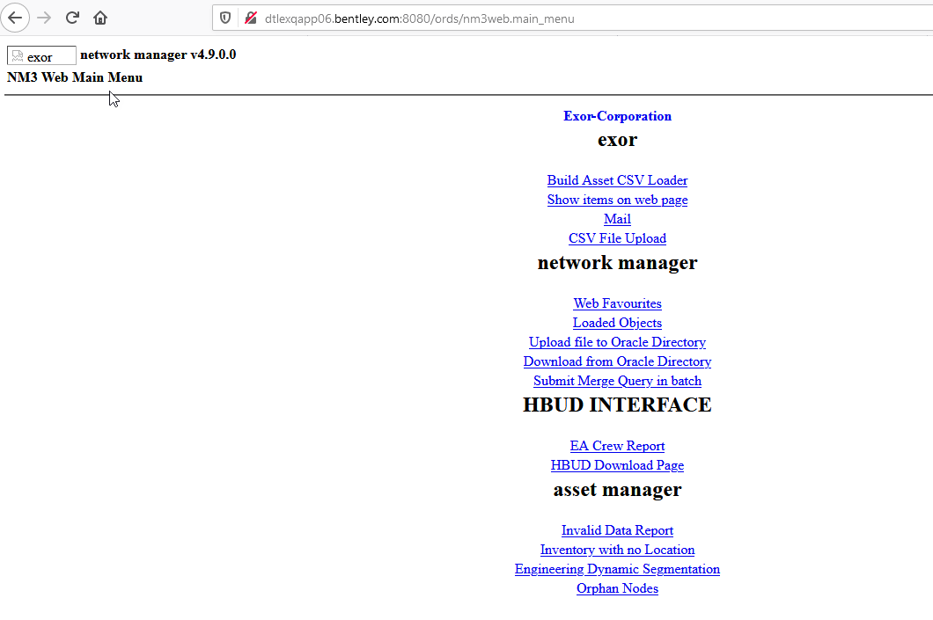

1. Launch WebLogic Enterprise Manager in a browser (<http://localhost:7001/console>) and highlight ‘Servers’ under Domain Structure:



1. Select the ‘Control’ Tab, select the checkbox next to the ORDS Server, eg: WLS_ORDS and force shutdown:

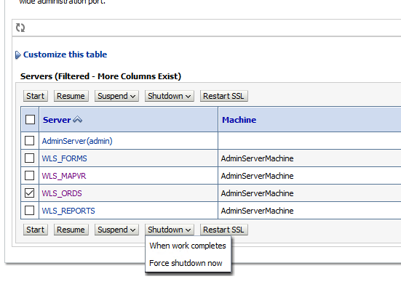

1. Go to Domain Structure > Deployments.
2. Click **Lock & Edit**
3. On the Deployments page, click on the Install button (above/below the list of deployments).



1. In the Install Application Assistant, under Locate deployment to install and prepare for deployment, populate the Path entry to ORDS directory path( eg C:\Oracle\Product\Middleware\ORDS), or navigate to the directory by highlighting the folders under Current Location. Select

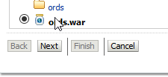

1. and click **Next**.
2. Under Choose targeting style, accept the default (Install this deployment as an application), and click Next.
3. In the Select deployment targets, under Servers select the cluster_mapviewer and click Next

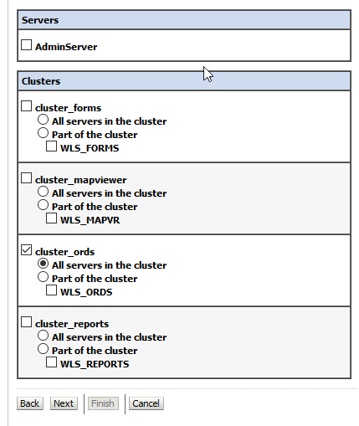

1. Under Optional Settings, accept the defaults except under Security select Custom Roles: Use roles that are defined in the Administration Console; use policies that are defined in the deployment descriptor. Click **Finish**
2. Click **Activate Changes** to activate the deployment.
3. Highlight ‘Servers’ under Domain Structure:



1. Select the ‘Control’ Tab, select the checkbox next to the ORDS Server, eg: WLS_ORDS and Start the ORDS Server

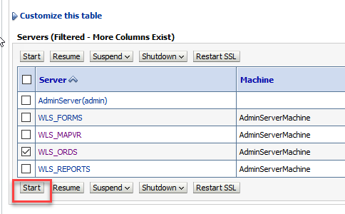

1. Highlight ‘Deployments’ under Domain Structure:
2. On the Summary of Deployments page select the Control Tab and select the just installed ords from the list. Click Start > Servicing all requests (above/below the Deployments list) and confirm the start by clicking on the Yes button on the following page

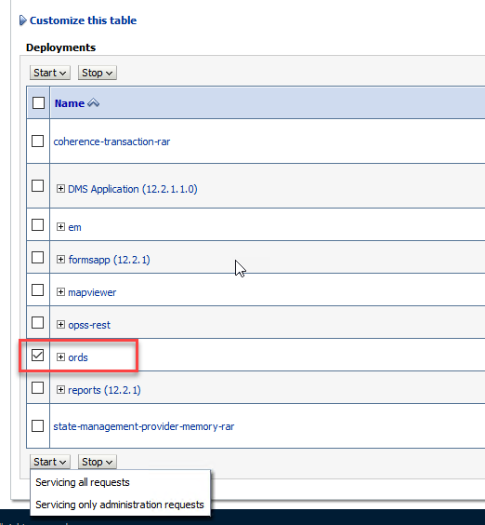

1. ords should now be started (with State: Active and Health: OK).

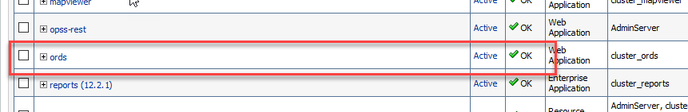

#### Migrating DADS files to ORDS

When deploying ORDS a connection pool was created in Step 10. This is a default connection pool, so to create a connection which corresponds to a DADS entry, the following steps should be followed:

* In ORDS_PATH/ords/params copy ords_params.properties to a new filename ie:

<Connection Pool Name>_ords_params.properties

Note: Connection Pool names need to be unique, we’ve found that the following is a useful naming convention:

<Connection Pool Name> = <Connection Name>_<DB SID>

Eg: tig_orek19p for a TIG connection to DB OREK19P

In this file modify the following:

db.hostname=<DB Host Name>  
db.username=<DB Username>  
db.password=!<DB password>  
db.port=<DB Port>  
db.servicename=<DB Service Name>

* Open a command window as administrator and change directory to ORDS_PATH
* Issue the following command to create the connection pool:

java -jar ords.war setup –database <Connection Pool Name>

When prompted, use the same values from the table in 9., above, apart from the following:

* + When prompted, enter [2]  to skip verifying/installing ORDS.
  + When prompted, enter [1] to use the PL/SQL Gateway
* Issue the following command to link the parameter file to the connection pool

java -jar ords.war setup --database <Connection Pool Name> --parameterFile params/<Connection Pool Name>_ords_params.properties

* Issue the following command to map the URL to the connection pool

java -jar ords.war map-url --type base-path /<Connection Pool Name> <Connection Pool Name>

* This will create the following XML file:

ORDS_PATH/ords/conf/<Connection Pool Name>.xml

DADS parameters can be mapped to corresponding ORDS parameters in this file. The table below indicates the DADS parameters and associated ORDS equivalents:

|  |  |
| --- | --- |
| DADS parameters | ORDS equivalent |
| PlsqlDatabaseUsername | db.username |
| PlsqlDatabasePassword | db.password |
| PlsqlDatabaseConnectString | Multiple Settings such as:  db.hostname db.port db.servicename db.sid |
| PlsqlAuthenticationMode | security.requestAuthenticationFunction |
| PlsqlSessionStateManagement | N/A |
| PlsqlDocumentTablename | owa.docTable |
| PlsqlDocumentPath | N/A |
| PlsqlDocumentProcedure | N/A |
| PlsqlDefaultPage | misc.defaultPage |
| PlsqlErrorStyle | debug.printDebugToScreen |

As an example, for DADS config:

<Location /area51c_nm3web>

SetHandler pls_handler

Order allow,deny

Allow from All

AllowOverride None

PlsqlDatabaseUsername <DB username>

PlsqlDatabasePassword <DB Password>

PlsqlDatabaseConnectString sgsprdodb01.bentleyhosting.com:1521:area51c SIDFormat

PlsqlAuthenticationMode Basic

PlsqlSessionStateManagement StatelessWithResetPackageState

PlsqlDocumentTablename nm_upload_files

PlsqlDocumentPath docs

PlsqlDocumentProcedure nm3web.process_download

PlsqlDefaultPage nm3web.main_menu

PlsqlErrorStyle DebugStyle

</Location>

The corresponding ORDS XML file would contain:

<properties>  
<entry key="db.password">@059B245BB5358142F47CBC8DF3273EC95D80CFA2A61B009A41</entry>  
<entry key="db.username">transinfo</entry>  
<entry key="db.servicename">OREK19P.bentley.com</entry>  
<entry key="owa.docTable">nm_upload_files</entry>  
<entry key="misc.defaultPage">nm3web.main_menu</entry>  
<entry key="debug.printDebugToScreen">DebugStyle</entry>  
</properties>

Please note, the DADS/ORDS XML mappings defined above may not correspond with what’s required for your environment. Please refer to the Oracle documentation for mapping mod_pl_sql settings to ORDS which contains a full list of parameter mappings.

#### Configuring WebLogic to Handle HTTP Basic Challenges Correctly

* Change directory to:

<Oracle Home>\oracle_common\common\bin

Eg. C:\Oracle\Product\Middleware\Oracle_Home\oracle_common\common\bin

* Issue the following command to start WLST:

wlst.cmd

* Connect to the Admin Server in online mode, using a command like:

connect("weblogic","weblogic_password","hostname:7001")

Where weblogic_password and hostname are the appropriate values for your environment

* Run the following WLST commands:

cd ('SecurityConfiguration/fmfr')  
edit()  
startEdit()  
set('EnforceValidBasicAuthCredentials','false')  
save()  
activate()  
disconnect()  
exit()

* Validate the ORDS setup by changing directory to the ORDS config directory (ie where ords.war is located) and issue the following command from a command window, run as Administrator:

java -jar ords.war configdir

This should return the config.dir value eg:

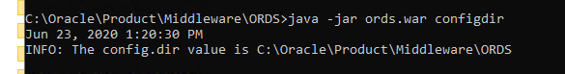

#### Test ORDS in Weblogic

* Test using the following URL:

http://<ORDS DB ServerName>:9004/ords/nm3web.main_menu

On successful configuration, you should be presented with a screen like:



### Configure WebUtil

Edit the file, using a suitable text editor, located in the folder <ORACLE_INSTANCE>\config\FormsComponent\forms\server called webutil.cfg. There are numerous options that can be configured in webutil.cfg relating to Logging, OS specifics, Upload/Download, and work areas. Initially we only configure the File Transfer which requires the following change to webutil.cfg

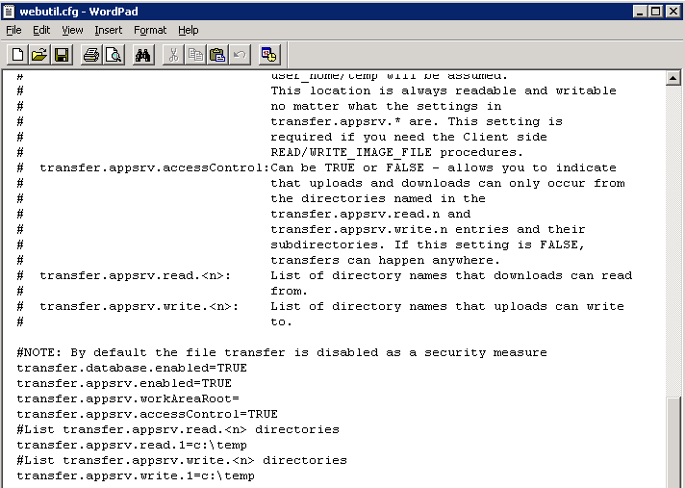

In the example above we have set the database and appsrv to be ‘TRUE’ with the default settings for transfer.appsrv.read and transfer.appsrv.write being at the default of c:\temp. We may need to add additional folders here to allow the upload on Maintenance Manager files etc to the specific Exor Directories.

## Post Install/Upgrade Tasks

### Creation of Additional Database Objects

* Change directory to <exor_base>\nm3\install
* Post install only, run the following from the command prompt:

import_nm_upload_files.bat

* **Post install and upgrade**, run the following from the command prompt:

ldjava_11g.bat

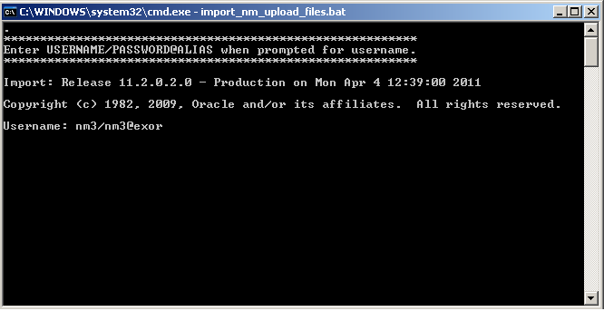

You will be prompted for the Username of the Highways Owner. Enter the Username/Password@alias then press Enter, e.g. nm3/nm3@exor

### Synonyms

Highways product option HIGPUBSYN is used to dictate whether or not Public database synonyms are used.

On first time installation of Network Manager synonyms are NOT created. So to create synonyms following installation, use the Highways application to set product option HIGPUBSYN and then within SQL*Plus run the following command;

EXECUTE nm3ddl.refresh_all_synonyms;

Note:

if you opt to not use Public Synonyms, then Private synonyms are created for all subordinate users when the above command is executed.

### Process Framework

The Process Framework can be started (or stopped) via the Process Framework Administration form (hig2550). After successfully completing installs or upgrades to 4.9.0.0 for all products required navigate to this form and use the Start Up button to start up the Process Framework.

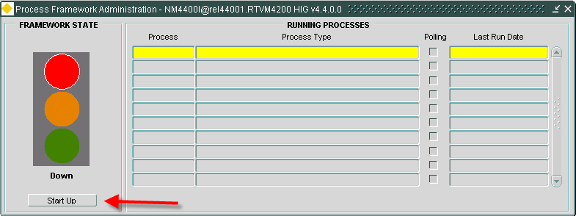

### Jobs

After completing a successful install/upgrade of Network Manager, please execute the following script to start/restart Core jobs:

* Change directory to <exor_base>\nm3\install
* Login to SQL*PLUS as the Highways Owner on the client PC

Run the following command:

start nm3jobs.sql

### Spatial Configuration

Specific information regarding the registration of spatial layers can be found in the “Locator and Web Mapping” document.

### Spatial Theme Creation

Once Network Configuration has been completed, spatial themes, to support Spatial Data Loader, can be created as follows:

* Change directory to <exor_base>\nm3\install
* Login to SQL*PLUS as the highways owner on the client PC
* Run the following command:

start sdl_themes.sql

### Spatial Index creation

Once Network Configuration has been completed, spatial indexes included in Network Manager can be created, as follows:

* Change directory to <exor_base>\nm3\install
* Login to SQL*PLUS as the highways owner on the client PC
* Run the following commands:

start 4800_spatial_indexes.sql

start sdl_spidx

### Mandatory Configuration

#### exor_version.txt

Before accessing Network Manager, you must check the file exor_version.txt.

This file is referenced in Windows Registry setting ‘EXOR_VERSION’ and by default can be located in the <exor_base>\11g_bin directory.

Ensure that the entry for Network Manager is set accordingly;

NET=4.9.0.0  
HIG=4.9.0.0  
AST=4.9.0.0  
DOC=4.9.0.0  
WMP=4.9.0.0

### EXOR_JPG.JAR

Copy the new EXOR_JPG.JAR from the <exor_base>/icons/java folder to the <forms_home>/java folder on the application server.

Users may need to clear their JRE caches to see the changes.

### Doc Bundle Loader

#### Oracle External Scheduler Jobs

* For databases that exist on a Windows Operating System – The OracleJobScheduler<instance> service MUST be running on the database server.
* For databases that exist on a Solaris/Linux Operating System – Relevant permissions to execute <db_home>/bin/extjob must be set in accordance with Oracle Documentation.
* External Jobs are not supported on any other platform.

# Accidents Manager

Prior to Accidents Manager Installation or Upgrade, please refer to the **Pre Installation/Upgrade** section.

## Database Server Install/Upgrade for Accidents Manager

This chapter provides details of steps involved in installing/upgrading the server components for Accidents Manager.

Important:

This product will require installing/upgrading after Network Manager.

### Install/Upgrade of Accidents Manager

To create the base data and objects for Accidents Manager modules;

* Change directory to <exor_base>\acc\install
* Login to SQL*PLUS as the highways owner on the client PC and run the following command:

  start acc_inst.sql

You will be prompted to enter the path of the location of your highways software. This should be name of the directory, including disk identifier and a trailing slash character, referred to as <exor_base>.

For example, if you installed your highways software in a directory called EXOR on your C drive, you would enter the following when prompted.

  C:\EXOR\

When you have supplied this value, you will be prompted to confirm that it is correct and asked whether you wish to continue.

If the value specified is not correct or does not end with a slash character, you will be given an error message and the installation script will abort. You will then need to login to SQL*PLUS again and rerun the script.

After confirming the <exor base> definition you will be prompted to enter the Admin Type Code.

When the script has completed, all the Accidents Manager objects and data will have been installed.

For installation:

acc4900_install_1_<date&time>.LOG

acc4900_install_2_<date&time>.LOG

For upgrade:

acc4900_upg_1_<date&time>.LOG

acc4900_upg_2_<date&time>.LOG

Please raise and attach the logs to a ticket with <http://selectservices.bentley.com> to allow Bentley (formerly exor) support staff to verify the upgrade has been successful.

Due to interdependencies between some Exor products, please ignore all compilation errors until all of your products have been upgraded.

## Application Server Install/Upgrade for Accidents Manager

### Deploy Product Binary files

Copy the contents of the **<exor_base>\acc\11g_bin** folder to the same location as the Network Manager files (see section 4.2.10)**.** This will be the location of the Forms/Reports for Accidents Manager.

## Post Install/Upgrade Tasks

### Mandatory Configuration

#### exor_version.txt

Before accessing Accidents Manager you must check the file exor_version.txt.

This file is referenced in Windows Registry setting ‘EXOR_VERSION’ and by default can be located in the <exor_base>\11g_bin directory.

Ensure that the entry for Accidents Manager is set accordingly;

ACC=4.9.0.0

### Product Licencing

Following first time installation you must licence the product for use.

To do this start highways by exor and invoke module HIG1890 from the Fastpath menu.

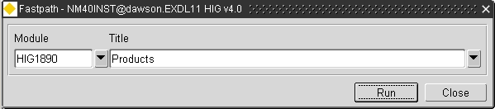

For further details please refer to the “Network Manager General System Admin Guide”

# Schemes Manager

Prior to Schemes Manager Installation or Upgrade, please refer to the **Pre Installation/Upgrade** section.

## Database Server Install/Upgrade for Schemes Manager

This chapter provides details of steps involved in installing/upgrading the server components for Schemes Manager.

Important:

This product will require installing/upgrading after Network Manager.

### Install/Upgrade of Schemes Manager

To create the base data and objects for Schemes Manager modules;

* Change directory to <exor_base>\stp\install
* Login to SQL*PLUS as the highways owner on the client PC and run the following command:

  start stp_inst.sql

You will be prompted to enter the path of the location of your highways software. This should be name of the directory, including disk identifier and a trailing slash character, referred to as <exor_base>.

For example, if you installed your highways software in a directory called EXOR on your C drive, you would enter the following when prompted.

  C:\EXOR\

When you have supplied this value, you will be prompted to confirm that it is correct and asked whether you wish to continue.

If the value specified is not correct or does not end with a slash character, you will be given an error message and the installation script will abort. You will then need to login to SQL*PLUS again and rerun the script.

After confirming the **<exor base>** definition you will be prompted to enter the Admin Type Code and Datum Network Type code associated with the Road Construction Inventory Type and associated Network Type Code.

When the script has completed, all the Schemes Manager objects and data will have been installed.

For installation:

stp4900_install_1_<date&time>.LOG

stp4900_install_2_<date&time>.LOG

For upgrade:

stp4900_upg_1_<date&time>.LOG

stp4900_upg_2_<date&time>.LOG

Please raise and attach the logs to a ticket with <http://selectservices.bentley.com> to allow Bentley (formerly exor) support staff to verify the upgrade has been successful.

Due to interdependencies between some Exor products, please ignore all compilation errors until all of your products have been upgraded.

## Application Server Install/Upgrade for Schemes Manager

### Deploy Product Binary files

Copy the contents of the **<exor_base>\stp\11g_bin** folder to the same location as the Network Manager files (see section 4.2.10)**.** This will be the location of the Forms/Reports for Schemes Manager.

## Post Install/Upgrade Tasks

### Mandatory Configuration

#### exor_version.txt

Before accessing Schemes Manager you must check the file exor_version.txt.

This file is referenced in Windows Registry setting ‘EXOR_VERSION’ and by default can be located in the <exor_base>\11g_bin directory.

Ensure that the entry for Schemes Manager is set accordingly;

STP=4.9.0.0

### Product Licencing

Following first time installation you must licence the product for use.

To do this start highways by exor and invoke module HIG1890 from the Fastpath menu.



For further details please refer to the “Network Manager General System Admin Guide”

# Structures Manager

Prior to Structures Manager Installation or Upgrade, please refer to the **Pre Installation/Upgrade** section.

## Database Server Install/Upgrade for Structures Manager

This chapter provides details of steps involved in installing/upgrading the server components for Structures Manager.

Important:

This product will require installing/upgrading after Network Manager.

### Install/Upgrade of Structures Manager

To create the base data and objects for Structures Manager modules;

* Change directory to <exor_base>\str\install
* Login to SQL*PLUS as the highways owner on the client PC and run the following command:

  start str_inst.sql

You will be prompted to enter the path of the location of your highways software. This should be name of the directory, including disk identifier and a trailing slash character, referred to as <exor_base>.

For example, if you installed your highways software in a directory called EXOR on your C drive, you would enter the following when prompted.

  C:\EXOR\

When you have supplied this value, you will be prompted to confirm that it is correct and asked whether you wish to continue.

If the value specified is not correct or does not end with a slash character, you will be given an error message and the installation script will abort. You will then need to login to SQL*PLUS again and rerun the script.

When the script has completed, all the Structures Manager objects and data will have been installed.

For installation:

str4900_install_1_<date&time>.LOG

str4900_install_2_<date&time>.LOG

For upgrade:

str4900_upg_1_<date&time>.LOG

str4900_upg_2_<date&time>.LOG

Please raise and attach the logs to a ticket with <http://selectservices.bentley.com> to allow Bentley (formerly exor) support staff to verify the upgrade has been successful.

Due to interdependencies between some Exor products, please ignore all compilation errors until all of your products have been upgraded.

## Application Server Install/Upgrade for Structures Manager

### Deploy Product Binary files

Copy the contents of the **<exor_base>\str\11g_bin** folder to the same location as the Network Manager files (see section 4.2.10)**.** This will be the location of the Forms/Reports for Structures Manager.

## Post Install/Upgrade Tasks

### Mandatory Configuration

#### exor_version.txt

Before accessing Structures Manager you must check the file exor_version.txt.

This file is referenced in Windows Registry setting ‘EXOR_VERSION’ and by default can be located in the <exor_base>\11g_bin directory.

Ensure that the entry for Structures Manager is set accordingly;

STR=4.9.0.0

### Product Licencing

Following first time installation you must licence the product for use.

To do this start highways by exor and invoke module HIG1890 from the Fastpath menu.



For further details please refer to the “Network Manager General System Admin Guide”